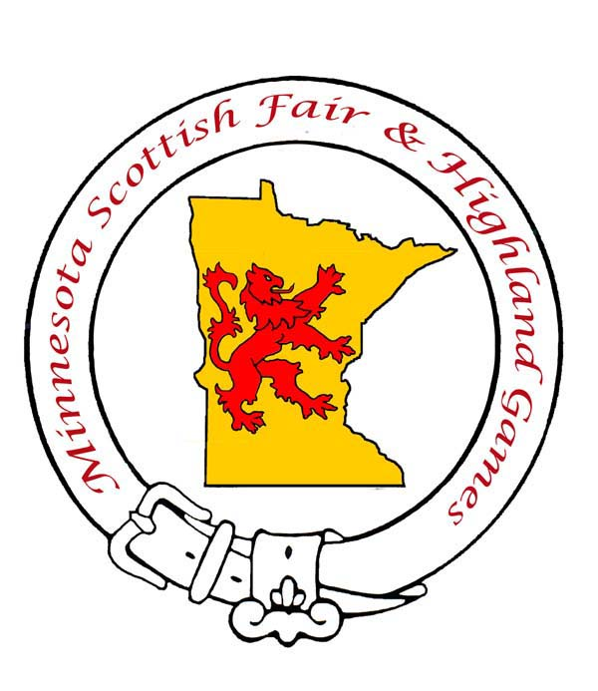
Don Cogswell, president
Minnesota Scottish Fair & Highland Games
1366 Camelback Dr.
Eagan, MN 55123
Cell: 651-283-0362
Home Phone: 651-687-9666
Email: dbcogswell@mnscottishfair.org
Webpage: www.mnscottishfair.org
April 18, 2017
Dear Prospective Sponsor:

The Minnesota Scottish Fair and Highland Games (MSF&HG) will be celebrating all things highland and we wish to invite you to be a part of the festivities!

You have an incredible opportunity to support this event that brings together communities across the globe by giving financially. Because the MSF&HG is run solely by volunteers and is backed by sponsors and donations, we are seeking area businesses and people alike who believe in this festival and what it does for our community and who wish to support the MSF&HG’s longevity.

Each level of giving is fully outlined in the attached sponsorship form and provides you the chance to choose which level of sponsorship you are interested in being a part of that supports MSF&HG as a whole. Knowing that the MSF&HG takes approximately $52,000 annually, to be fully funded, we are reaching out to you and asking you to seriously consider your commitment in seeing the MSF&HG’s success for this year and years to come.

Commitments must be solidified by 3 weeks prior to the games. Please fill out the attached sponsorship form and return to:

MSF&HG at c/o Don Cogswell, 1366 Camelback Dr., Eagan, MN 55123

We look forward to continuing our Scottish celebrations in Scotland, USA, and with your support we know it can happen!

Thank you again for considering.

Best regards,

Don Cogswell, president
Minnesota Scottish Fair & Highland Games

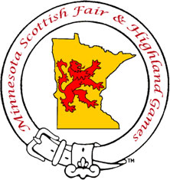
Minnesota Scottish Fair & Highland Games
SPONSORSHIP FORM
Please return this form and check made out to
“MN Scottish Fair” to:
MN Scottish Fair
c/o Don Cogswell
1366 Camelback Dr.
Eagan, MN 55123

Company/Organization: ___________________________________________________________________________ Contact Name: __________________________________________________________________________________
Address: ___________________________________City: ________________________ State: _______ Zip: ________
E-mail address: ________________________________________ Phone number: (______)_______- _____________
Website for us to get logo (if applicable): _________________________________________________________
*T-shirt sizes (men’s sizes): S___________M___________L___________
Donation Information: (Please check appropriate box)

☐ Thistle Society – $2000 and up
8 gate passes to the MSF&HG, 8 sponsor badges, 8 VIP seats for the opening and closing ceremonies, 2 games t-shirts*, name recognition in the program and MSF&HG website, recognition throughout the day over the PA system, full page advertisement in program. Pipe band to play at an upcoming event, prior to the next years’ games.
☐ Heather Society – $1000 - $1999
6 gate passes to the MSF&HG, 6 sponsor badges, 6 VIP seats for the opening and closing ceremonies, 2 games t-shirts*, name recognition in program and MSF&HG website, recognition throughout the day over the PA system, half page advertisement in program. Solo piper to play at an upcoming event prior to next years’ games.
☐ Burns Society – $500 - $999
4 gate passes to the MSF&HG, 4 sponsor badges, 2 VIP seats for the opening and closing ceremonies, 1 games t-shirt*, name recognition in program and MSF&HG website, 1/4 page advertisement in program.
☐ Tartan Society – $250 - $499
2 gate passes to the MSF&HG, 2 sponsor badges, 1 games t-shirt*, name recognition in program and MSF&HG website.
☐ Scottish Society – $100 - $249
2 gate passes to MSF&HG, 2 sponsor badges, name recognition in program and MSF&HG website.

